PE Funding

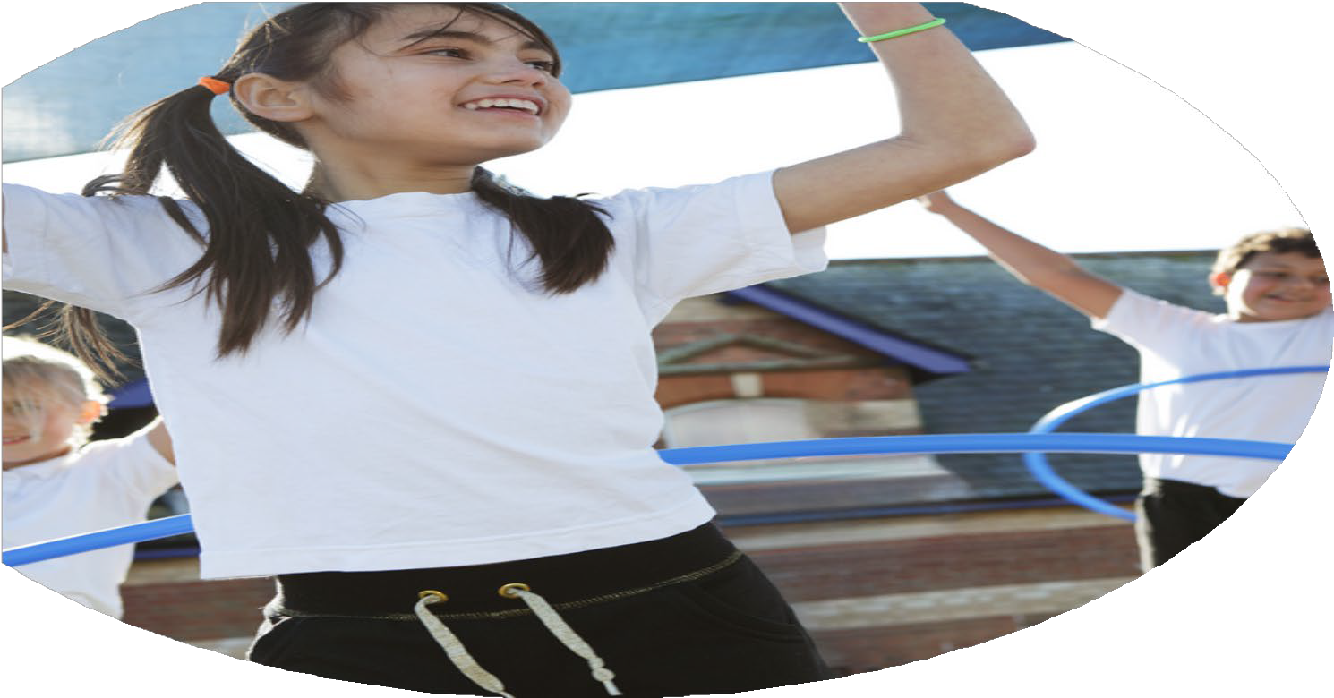

Evaluation Form

**Commissioned by**

**Created by**

Images courtesy of Youth Sport Trust

**PE Funding Evaluation Form**

 It is intended that this template should be used as preparation for the completion of the statutory digital reporting tool being introduced this academic year. You can upload data (including swimming) from this template onto this platform once it becomes accessible.

 Before you decide how you are going to use the funding for this academic year you should reflect and evaluate the impact of your use of the funding in 2023/24.

 All spending of the funding must conform with the terms outlined in the Conditions of Grant document.  The template is a working document that you can amend/update during the year.

 Based on your evaluation of last year’s funding you should decide what you intend to do this academic year, how you will do it, and what impact you expect it to have.

It is important that the funding is used effectively and based on your school’s needs.

 You must use the funding to make additional and sustainable improvements to the PE and sport in your school.  You must develop and add to the PESSPA activities that your school already offers.

*Summative digital reporting from June 2025 will continue to include swimming and water safety information therefore funding can be used to provide top-up lessons where necessary to ensure pupils meet national curriculum swimming requirements.*

**We recommend that you start by reflecting on the impact of current provision and reviewing your previous spend**

|  |  |  |  |
| --- | --- | --- | --- |
| What went well? | How do you know? | What didn’t go well? | How do you know? |
| Effective implementation of 60 active minutes.  Effective 30 active minutes which is part of Eight Principles of an Active School.  Equal opportunities for all regardless of gender.  Staff Continuing professional development | Schools Games Mark Gold area.  Schools Games Mark Gold area.  Schools Games Mark Gold area.  Schools Games Mark Gold area, Staff Survey | Transition support-targeted offer that focuses on those children.  KS1 Extracurricular clubs. | Schools Games Mark Silver area.  Uptake was low compared to KS2. |

|  |  |
| --- | --- |
| What are your plans for 2024/25? | How are you going to action and achieve these plans? |
| Intent | Implementation |
| 1, Increasing all staff’s confidence, knowledge and skills in teaching physical education and sport.  2, Offer a broader and equal experience of a range of sports and physical activities to all pupils. Providing extracurricular opportunities for all children to enable them to access other sporting activities and specialist sport instruction.  3, Entering local school competitions and holding inter-house competitions in the school to encourage participation. | 1, Utilising a sports coach to work in partnership with the teachers to upskill them through formal CPD, modelling lessons, team teaching and lesson observation and feedback.  Lunchtime supervisors will be trained to engage wider school staff in the delivery of school sport and physical activity.  Make use of online digital portals to gain access to quality CPD courses.  2, Ensure the extracurricular activities reinforce and complement the children development in PE.  Ensure clubs that are available are balanced and varied.  Reach out to providers in the local community eg sports clubs to see if they can deliver a taster session to encourage children to attend.  3, Renew membership to the South Charnwood Sports Network.  Create a calendar that demonstrates opportunities for all young people regardless of sex, educational need or other targeted groups. These competitions will be spread across all year groups ensuring equal opportunities. This calendar will showcase the various competitions we can take part in. |

|  |  |
| --- | --- |
| What impact/intended impact/sustainability are you  expecting? | How will you know? What **evidence** do you have or  expect to have? |
| 1, The questionnaire shows teachers becoming increasingly confidence and skilled in the delivery of PE. Following questionnaire, targeted CPD will be offered for members of staff where increased knowledge of skills are needed.  2, Bigger uptake for our extracurricular activities across the school, particularly KS1. Pupil voice will show children are enjoying the sports on offer and have a positive view around sports outside of structured lessons.  3, Children will experience sport in lesson and then take part in free competitions run by the PE lead or external competitions. They will have the opportunity to develop their skills and be chosen to represent Eastfield. | 1, Confidence and understanding of staff members to be evaluated through staff questionnaire and data collection is to be acted on appropriately.  2, Pupil voice on their views of the extracurricular sports we provide is positive. More children across the school are attending our extra curriculum sports offer. More children are joining sports club’s/leisure centers outside of school.  3, Children will be taking part in a wide range of competitive sports. Children regardless of their sex, educational need or other target groups will be taking part in competitive sports where the focus is on the experience rather than the outcome. |

|  |  |
| --- | --- |
| What **impact/sustainability** have you seen? | What **evidence** do you have? |
|  |  |